In this video we will discuss the use of **Grouping function in SQL Server**.    
  
   
  
This is continuation to [Part 104](http://csharp-video-tutorials.blogspot.com/2015/09/difference-between-cube-and-rollup-in.html). Please watch [Part 104](http://csharp-video-tutorials.blogspot.com/2015/09/difference-between-cube-and-rollup-in.html) from [SQL Server tutorial](https://www.youtube.com/playlist?list=PL08903FB7ACA1C2FB) before proceeding. We will use the following Sales table for this example.  
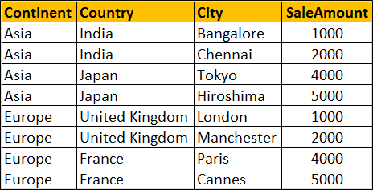   
  
**What is Grouping function**  
Grouping(Column) indicates whether the column in a GROUP BY list is aggregated or not. Grouping returns 1 for aggregated or 0 for not aggregated in the result set.   
  
The following query returns 1 for aggregated or 0 for not aggregated in the result set

SELECT   Continent, Country, City, SUM(SaleAmount) AS TotalSales,

         GROUPING(Continent) AS GP_Continent,

         GROUPING(Country) AS GP_Country,

         GROUPING(City) AS GP_City

FROM Sales

GROUP BY ROLLUP(Continent, Country, City)

**Result :**  
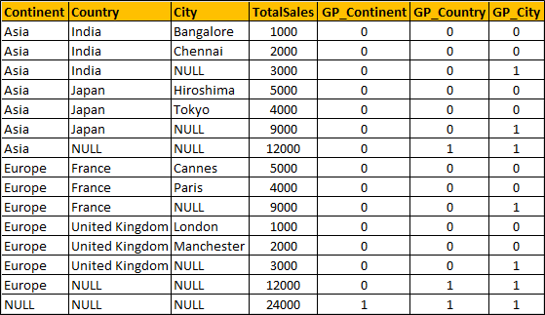   
  
**What is the use of Grouping function in real world**  
When a column is aggregated in the result set, the column will have a NULL value. If you want to replace NULL with All then this GROUPING function is very handy.

SELECT

    CASE WHEN

         GROUPING(Continent) = 1 THEN 'All' ELSE ISNULL(Continent, 'Unknown')

    END AS Continent,

    CASE WHEN

         GROUPING(Country) = 1 THEN 'All' ELSE ISNULL(Country, 'Unknown')

    END AS Country,

    CASE

         WHEN GROUPING(City) = 1 THEN 'All' ELSE ISNULL(City, 'Unknown')

    END AS City,

    SUM(SaleAmount) AS TotalSales

FROM Sales

GROUP BY ROLLUP(Continent, Country, City)

Result :   
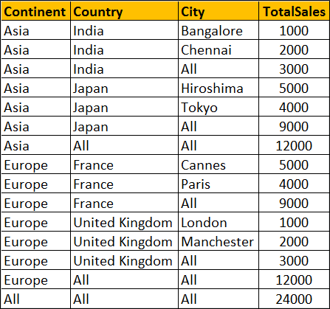   
  
**Can't I use ISNULL function instead as shown below**

SELECT   ISNULL(Continent, 'All') AS Continent,

         ISNULL(Country, 'All') AS Country,

         ISNULL(City, 'All') AS City,

         SUM(SaleAmount) AS TotalSales

FROM Sales

GROUP BY ROLLUP(Continent, Country, City)

Well, you can, but only if your data does not contain NULL values. Let me explain what I mean.  
  
At the moment the raw data in our Sales has no NULL values. Let's introduce a NULL value in the City column of the row where Id = 1

Update Sales Set City = NULL where Id = 1

Now execute the following query with ISNULL function

SELECT   ISNULL(Continent, 'All') AS Continent,

         ISNULL(Country, 'All') AS Country,

         ISNULL(City, 'All') AS City,

         SUM(SaleAmount) AS TotalSales

FROM Sales

GROUP BY ROLLUP(Continent, Country, City)

**Result :** Notice that the actuall NULL value in the raw data is also replaced with the word 'All', which is incorrect. Hence the need for Grouping function.  
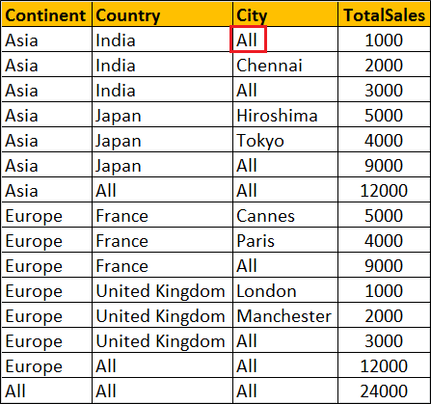   
  
**Please note :** Grouping function can be used with Rollup, Cube and Grouping Sets